Ideation Phase
Brainstorm & Idea Prioritization Template

Date | 30 September 2026
Team ID | SWTID-2026-8886
Project Name | Implement Client Script and UI Policy for Incident
Maximum Marks | 4 Marks

Brainstorm & Idea Prioritization Template:
Brainstorming provides a free and open environment that encourages everyone within a team to participate in the creative thinking process that leads to problem solving. Prioritizing volume over value, out-of-the-box ideas are welcome and built upon, and all participants are encouraged to collaborate, helping each other develop a rich amount of creative solutions.
Use this template in your own brainstorming sessions so your team can unleash their imagination and start shaping concepts even if you're not sitting in the same room.
Reference: https://www.mural.co/templates/brainstorm-and-idea-prioritization
Step-1: Team Gathering, Collaboration and Select the Problem Statement
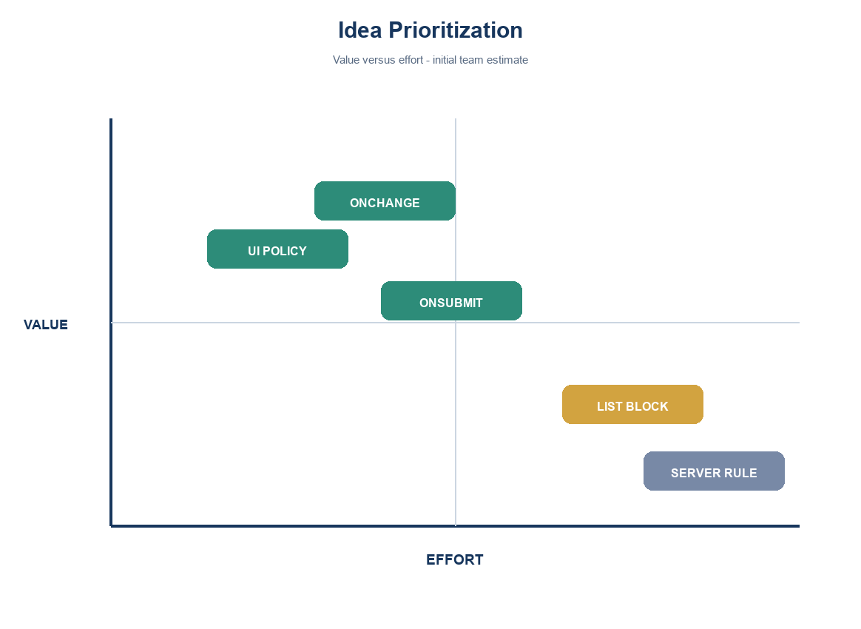

Step-2: Brainstorm, Idea Listing and Grouping
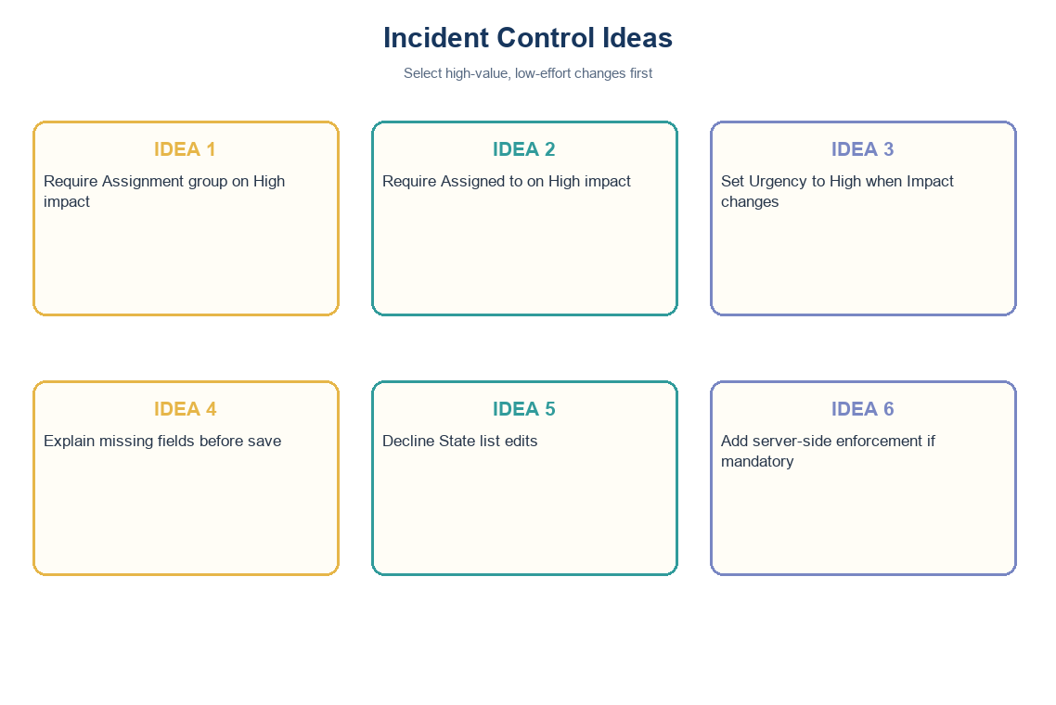

Step-3: Idea Prioritization
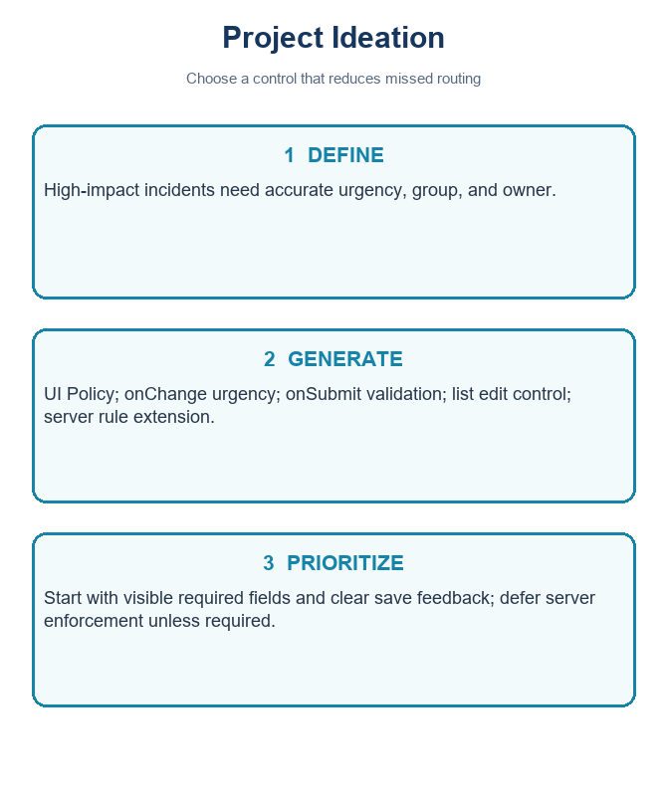
Idea | Value | Effort | Decision
UI Policy requires group and assignee | High | Low | Do first
onChange sets Urgency High | High | Low | Do first
onSubmit explains missing routing | High | Low | Do first
onCellEdit blocks State list change | Medium | Low | Demonstrate; not security
Server-side validation | High if policy | Medium | Future extension
Project note: values use the standard Incident choices where Impact 1 and Urgency 1 represent High. Confirm field names and values in the target instance.

